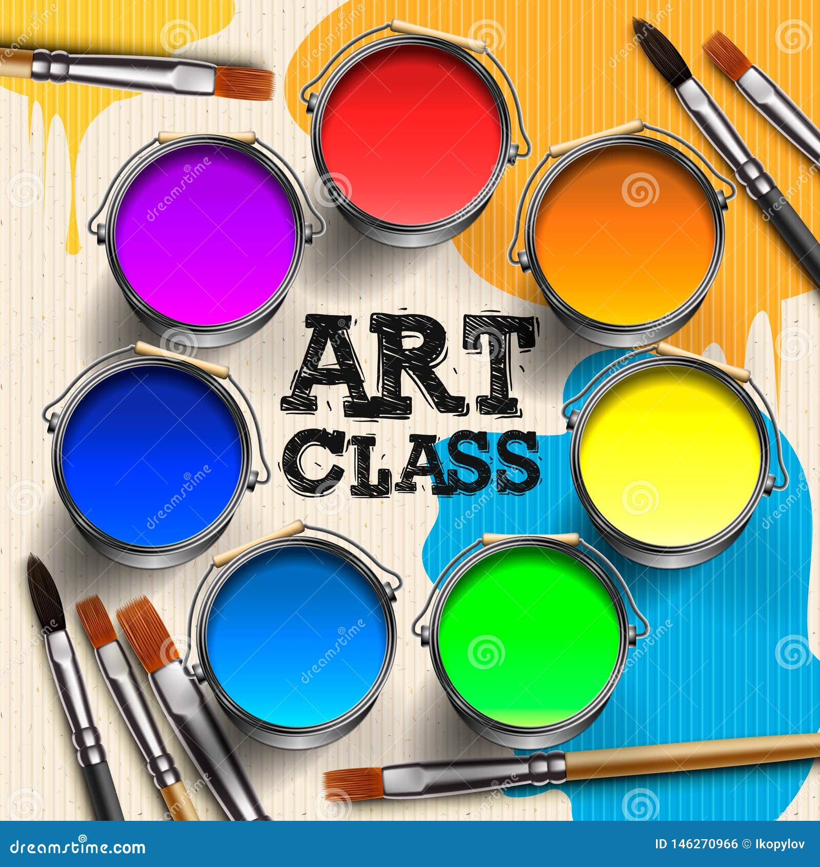

**🎨 Middle School Visual Art Syllabus**

**Instructor: Ms. Joyner**

**Grade Level:** 6–8  
**Course Duration:** Semester / Full Year  
**Contact Info:** JoyneSh@richmond.k12.ga.us  
**Classroom:** 702  
**Office Hours:** 8:30-4:30

**✳️ Course Description:**

This course introduces students to foundational art concepts, techniques, and art history. Students will explore a variety of mediums, develop their creative expression, and learn how to analyze and critique visual art. The focus is on building technical skills, creativity, and visual literacy.

**🎯 Course Objectives:**

By the end of the course, students will be able to:

* Understand and apply the elements of art and principles of design
* Use a variety of media and tools (pencil, paint, clay, digital art, etc.)
* Create original artwork that reflects personal ideas and emotions
* Analyze and critique works of art using art vocabulary
* Learn about artists and art movements from different cultures and time periods

**🧰 Materials Needed:**

* Sketchbook (provided or required)
* Pencil, eraser, colored pencils
* Ruler, scissors, glue stick
* Any additional supplies will be provided or listed in advance

**📚 Units of Study:**

**Quarter 1:**

* **Introduction to the Elements of Art**: Line, Shape, Color, Value, Texture, Space, Form
* **Drawing Techniques**: Contour, shading, perspective
* **Famous Artists Focus**: Picasso, Georgia O’Keeffe

**Quarter 2:**

* **Principles of Design**: Balance, Contrast, Emphasis, Movement, Pattern, Rhythm, Unity
* **Painting & Color Theory**: Warm/cool colors, complementary, analogous
* **Art Movements**: Impressionism, Abstract Art

**Quarter 3:**

* **3D Art & Sculpture**: Clay, paper mâché, assemblage
* **Multicultural Art**: African masks, Japanese printmaking, Native American pottery
* **Collaborative Art Project**

**Quarter 4:**

* **Digital Art / Mixed Media**
* **Art Criticism and Reflection**
* **Final Portfolio & Student Exhibition**

**📈 Assessment & Grading:**

* **Class Participation & Effort** – 25%
* **Projects / Artwork** – 40%
* **Sketchbook / Homework Assignments** – 15%
* **Quizzes / Art Critiques / Artist Studies** – 10%
* **Final Portfolio / Exhibition** – 10%

Rubrics will be used to assess creativity, craftsmanship, following directions, and improvement.

**👩‍🎨 Classroom Expectations:**

* Respect your artwork, others’ work, and classroom materials
* Follow directions and use time wisely
* Clean up your workspace
* Participate and try your best—creativity is a process!

**🔁 Make-up & Late Work Policy:**

Students who miss class are responsible for checking in and making up missed work within one week. Late work may receive partial credit unless excused.

Parent Signature is required to receive extra credit!!

Parents Name (Print)________________________________________________

Parents Signature___________________________________________________